**Scenario: User bypasses SSL warning**

**Step: Launch "expired_page" WebPage - PASS**

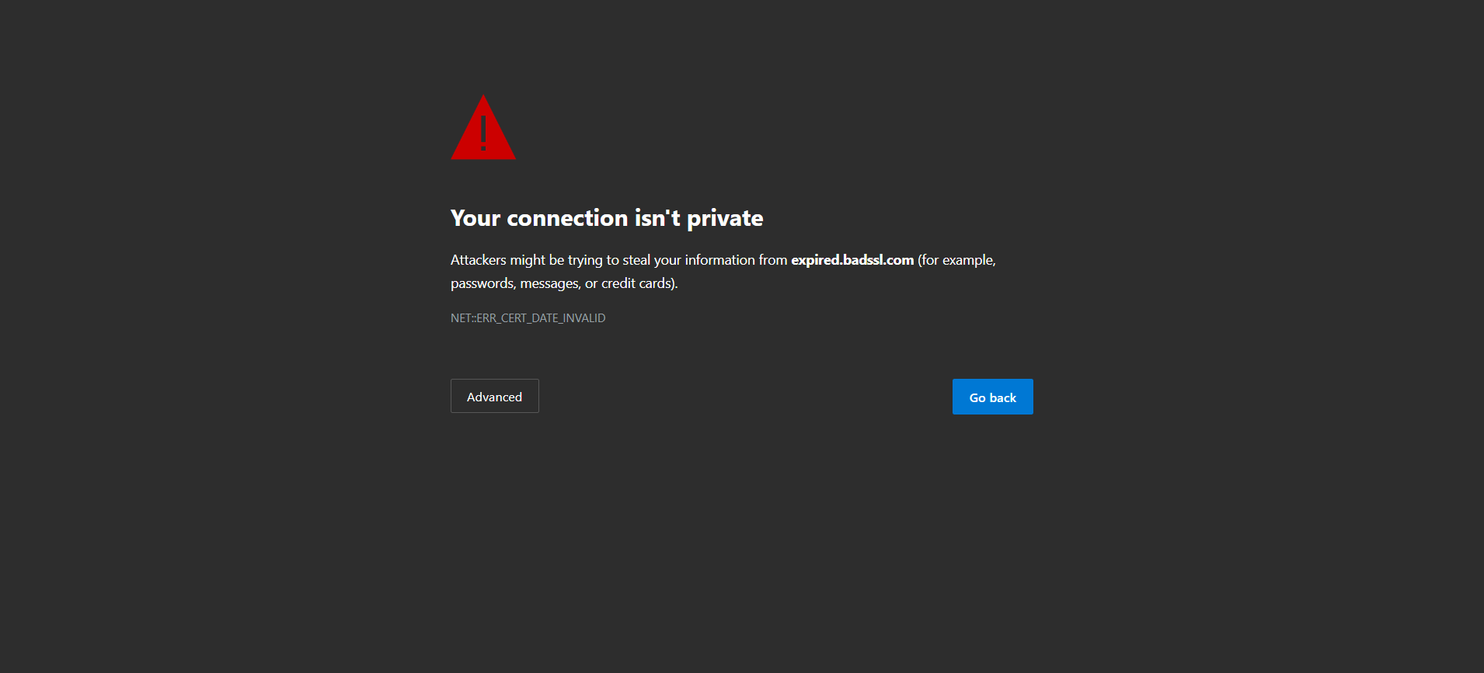

**Step: When the user clicks the Advanced option and clicks Proceed - PASS**



**Step: Then the user validate the page with title"expired.badssl.cm" and URL "https://expired.badssl.com/" - PASS**



**Execution Summary:  
Total Steps: 3  
Passed: 3  
Failed: 0**